

CHILD CENTRED PROVISION

We will organise activities within our school to promote health & wellbeing and cyber safety and continue to raise self esteem

We will share learning outcomes with pupils and share individual improvement targets

We will analyse data and make observations to ensure pupil work is matched to ability, particularly after the long absence from school caused by lockdown

We will arrange short term interventions to build confidence and close learning gaps

We will keep parents informed of ways to help their child in school

HIGH QUALITY TEACHING & LEARNING

We will continue to develop investigative skills in World around Us topic work

We will continue to develop problem solving skills and strategies in Maths

We will introduce extended writing to P3, and continue Reciprocal Reading

We will encourage active learning in Play Based/ Activity based learning and enable pupils to apply skills from Literacy, Numeracy and ICT

We will develop creativity in ICT using Green Screen and iPad apps

P1-3

All schools must have a 3 year development plan and this is the first year of our plan which will run from 2018 to 2021. This summary has been designed so that you, as parents and guardians, are aware of the areas we are working on in the coming year.

We have great pride in the ethos and the work of Belmont but continually strive to improve what we do. The development areas are devised from rigorous self evaluation and review, an analysis of results, parent questionnaire responses and detailed audits with governors and both teaching and non- teaching staff.

All of the excellent practices and procedures we have will continue and as always, the children are at the heart of every decision made. If you have any comments or suggestions, please email [omcilroy509@c2kni.net](mailto:omcilroy509@c2kni.net)

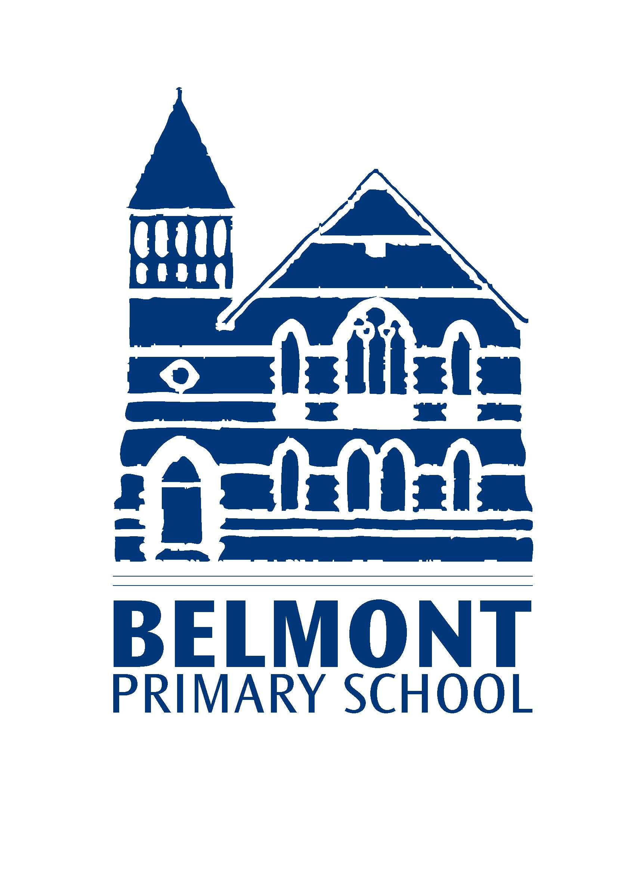

SCHOOL CONNECTED TO COMMUNITY

We will organise Covid safe procedures to keep parents informed and involved

We will add weekly classwork details to our new home learning portal to keep parents aware of class learning

We will be inventive with activities that enhance topics and build interests.

We will be involved in local competitions and support charities at home and abroad

EFFECTIVE LEADERSHIP

We will arrange virtual training and awareness sessions for our governors

We will arrange further virtual training for Senior Management, Subject coordinators, class teachers and classroom assistants to ensure we stay abreast with new initiatives and statutory requirements

We will carry out regular risk assessments to ensure pupil safety, particularly in light of Covid 19 and protect pupils in bubbles.

We will continue to work with partner schools to ensure procedures and good practices between the 4 schools are shared.

We will analyse parent questionnaires responses and take action where appropriate

**What are we doing to improve our school this year?**

**2020/2021**